Sons of the American Legion
Cecil Squadron #15 Presents
Come support a worthy cause!
All proceeds stay in Cecil County!

2020 ICE SPLASH
February 29, 2020
The Wellwood Yacht Club, Charlestown MD
Registration opens at 11:30am; Approximate 1:00pm Splash Time
Food & beverages available on-site for purchase.
Event Participant Tier Levels
Gold Splasher (Minimum $50 Donation) receive an Event Sweatshirt
Silver Splasher (Minimum $25 Donation) receive an Event Branded (TBD)
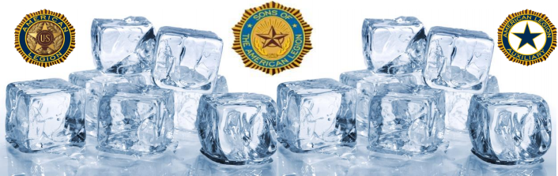
Become a sponsor or form a team today!
For questions visit our Facebook page or use the contact us form on our website
Details and links to the Ice Splash documents can be found on our
Website @ www.alpost15.com/ice-splash
All proceeds will benefit the Cecil County Public Schools Corollary Sports Program and Cecil County Special Olympics

